Sunday Discoverers… at home!

John 14: 15-21
Jesus promises his disciples that God will send the Spirit of truth, who will be with them for ever. He reminds them that those who love him are those who keep his commandments. These are the ones to whom he will reveal himself.

Bible Story:
John 14: 15-21 (International Children’s Bible)

The Promise of the Holy Spirit:
¹⁵ “If you love me, you will do the things I command. ¹⁶ I will ask the Father, and he will give you another Helper. He will give you this Helper to be with you forever. ¹⁷ The Helper is the Spirit of truth. The world cannot accept him because it does not see him or know him. But you know him. He lives with you and he will be in you.
¹⁸ “I will not leave you all alone like orphans. I will come back to you. ¹⁹ In a little while the world will not see me anymore, but you will see me. Because I live, you will live, too. ²⁰ On that day you will know that I am in my Father. You will know that you are in me and I am in you. ²¹ He who knows my commands and obeys them is the one who loves me. And my Father will love him who loves me. I will love him and will show myself to him.”

Reflection Points:
- What do you think Jesus means when he says that the Holy Spirit will ‘live in you’?
- Can you think of an example where you’ve kept a rule because you love someone?
- If we love Jesus and try to show his love, what difference might that make to the other people we know?

Just Love:
Create a reminder to keep Jesus’ great commandment
You will need: red card, white card, scissors, pens, glue, safety pins, sticky tape.
- Cut out 2 heart shapes; one on a red piece of paper, one on a white piece of paper.
- Write the word ‘love’ in the middle of your white heart.
- Then cut the red heart in half (vertically) and glue the outer curved parts of each side onto the white heart, so they fold open like a door.
- Then tape a safety pin to the back of the white heart to make it into a badge
Jesus’ big instruction to us was to love one another. If we love one another, it can show what Jesus is like.

Prayer:
Spirit, be beside:
those we love and those who love us,
those who are sad or ill,
those who are hungry,
thirsty or without shelter.
Spirit, be beside:
those who live in war zones,
those affected by climate change,
all God’s children around the world.
We pray that the Holy Spirit
will be with us
in our prayers, and in our lives.
Amen.

This Weeks Action:
Be aware of when you are following any rules this week.
Remember to think about Jesus’ commandments and how, if we follow them, we are showing him we love him- wear you’re badge to remind yourself of his!

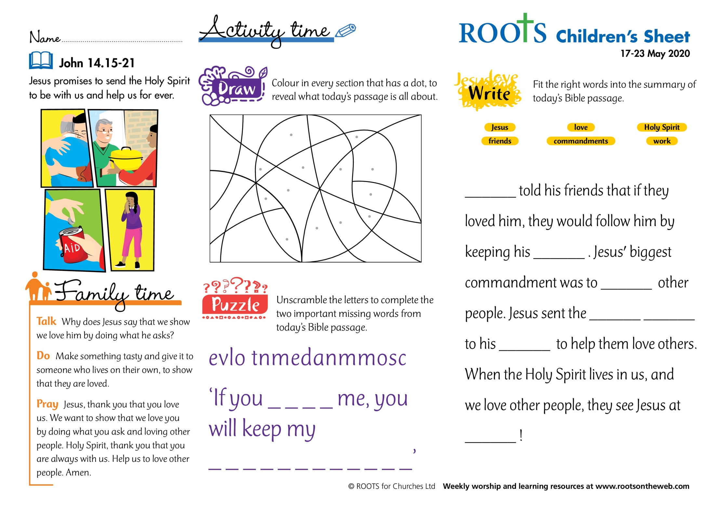
Activity Sheets:

