Sunday Discoverers… at home!
Luke 8: 22-25
Bible Story:

Luke 8: 22-25 (International Children’s Bible)

Jesus Stops a Storm:
²² One day Jesus and his followers got into a boat. He said to them, “Come with me across the lake.” And so they started across. ²³ While they were sailing, Jesus fell asleep. A big storm blew up on the lake. The boat began to fill with water, and they were in danger.
²⁴ The followers went to Jesus and woke him. They said, “Master! Master! We will drown!”
Jesus got up and gave a command to the wind and the waves. The wind stopped, and the lake became calm. ²⁵ Jesus said to his followers, “Where is your faith?”
The followers were afraid and amazed. They said to each other, “What kind of man is this? He commands the wind and the water, and they obey him!”

Reflection Points:
- During the time of lockdown what have you enjoyed?
  - Spending time with family?
  - Being in the garden lots?
- What have you found hard- perhaps it felt like you were in the storm?
  - Missing friends and going out?
  - Maybe even missing school!

Making a Mast
- Make a boat structure out of tin foil.
- Then fold a piece of plain paper in half and cut out a triangle or rectangle shape over the fold – to make a flag for your boat.
- Then using a stick as a mast (maybe an old chopstick/BBQ skewer etc.) attach your flag by wrapping it around the stick and gluing the flaps together.
- Then think about the reflection points above.
- On your flag write something that makes you happy and something that makes you sad.
- Thank God for the good things, and ask Him to help you through the storm too.
- Decorate your flag too (if you want).
- Attach your flag to your boat- and there you have it, a masterpiece!
(See some examples below)

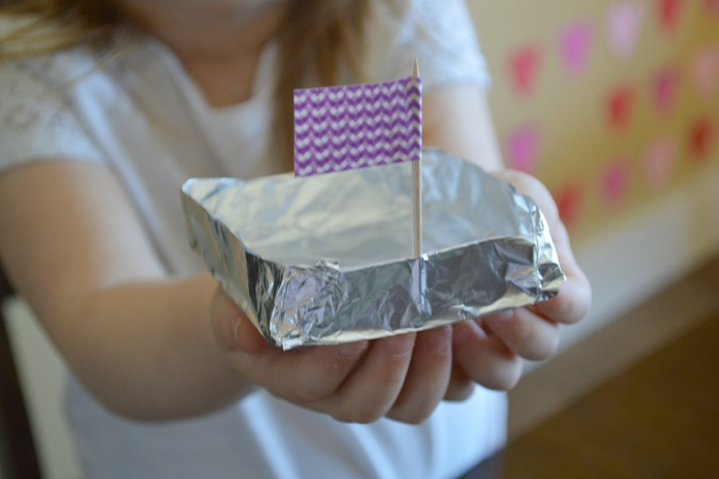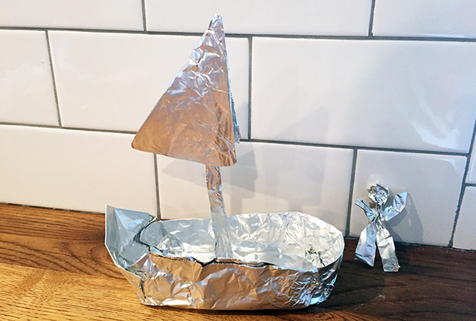

Prayer:
When stormy times come to us,
When we can't see a way out of our problems,
When everything seems to go wrong,
When our fears threaten to drown our faith,
When we are full of doubts and anger,
When it feels like you just aren't there,
When stormy times come upon us,
Help us, Jesus, to trust in you.
Amen.

This Weeks Action:
Sit your boat with your mast somewhere in your room to remind you God is always there for us; in the calm and stormy weather.
When you’re feeling remember the happy things!

Activity Sheets:
