*8.00am*– Holy Communion BCP Said at St Mary’s.

*9.30am* – Outdoor Songs of Praise at St Mary’s.

*11.00am* – Outdoor Songs of Praise at Holy Trinity.

**Newsletter**

**31st July 2022**

**Services This Week**

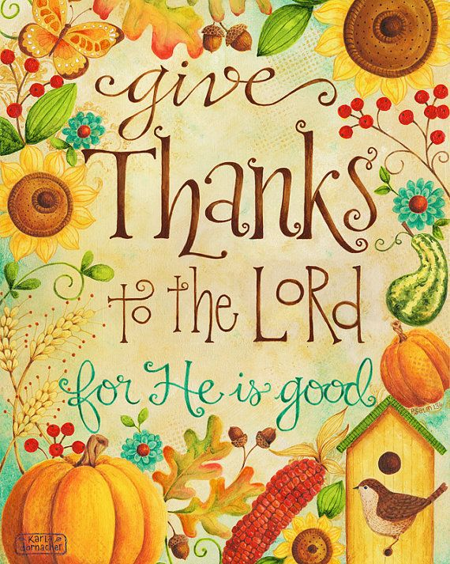

* **Sunday 7th August**

*Psalm 34: Psalm of Thanksgiving*

 No Service at St Mary’s 

*11am*– Matins with Holy Communion BCP at Holy Trinity.

*6.30pm* – Choral Evensong at Holy Trinity.



* **Sunday 14th August**

*Psalm 51: Psalm of Confession*

*9.30am* – Holy Communion at St Mary’s, with

a Baptism

 No Service at Holy Trinity 

**Services Throughout August**



Our theme for this week is Songs of Praise

* **Sunday 21st August**

*Psalm 13: Psalm of Lament*

 No Service at St Mary’s 

*11am* – Matins with Holy Communion BCP at Holy Trinity.



* **Sunday 28th August**

*Psalm 138: Psalm of Worship*

*9.30am* – Holy Communion at St Mary’s,

with a Baptism

No Service at Holy Trinity





**Collect Prayers**

Generous God,

you give us gifts and make them grow:

though our faith is small as mustard seed,

make it grow to your glory

and the flourishing of your kingdom;

through Jesus Christ our Lord.

**Amen**

**Readings**

**Psalm 100**

Make a joyful noise unto the Lord, all ye lands.

**2**Serve the Lord with gladness: come before his presence with singing.

**3**Know ye that the Lord he is God: it is he that hath made us, and not we ourselves; we are his people, and the sheep of his pasture.

**4**Enter into his gates with thanksgiving, and into his courts with praise: be thankful unto him, and bless his name.

**5**For the Lord is good; his mercy is everlasting; and his truth endureth to all generations.

Lord of all power and might,

the author and giver of all good things:

graft in our hearts the love of your name,

increase in us true religion,

nourish us with all goodness,

and of your great mercy keep us in the same;

through Jesus Christ your Son our Lord,

who is alive and reigns with you,

in the unity of the Holy Spirit,

one God, now and for ever.

**Amen**

**Ephesians 3: 14-21**

14 For this reason I kneel before the Father, 15 from

whom every family in heaven and on earth derives its name.

16 I pray that out of his glorious riches he may

strengthen you with power through his Spirit in your

inner being,

17 so that Christ may dwell in your

hearts through faith. And I pray that you, being

rooted and established in love,

18 may have power,

together with all the Lord’s holy people, to grasp how

wide and long and high and deep is the love of

Christ,

19 and to know this love that surpasses

knowledge—that you may be filled to the measure of

all the fullness of God.

20 Now to him who is able to do immeasurably more

than all we ask or imagine, according to his power that

is at work within us, 21 to him be glory in the church

and in Christ Jesus throughout all generations, for ever

and ever! Amen.



This is me!

My name is Kate Dillingham and for the last 2 years I have worked as ministry Associate at All Saints Crowborough, this role included running kids and youth groups, bible study groups for teenage girls, toddler groups and day to day ministry.

Also, I have had the pleasure of helping at connect@5 at Hartfield. I have been running bible studies and growing those relationships with the girls who come. I have loved getting to know them and studying the Bible with them. I am really looking forward to working at Hartfield, meeting and getting to know the children and families, getting to know all of you. I am looking forward to seeing what God has store for this church.

I can’t wait to be working at Hartfield church and linking in with the school.

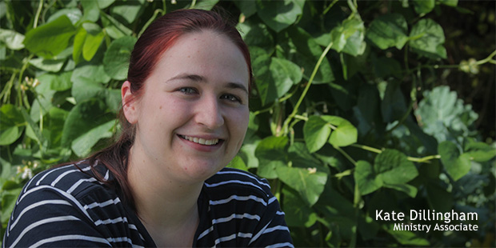



**Websites**

Please take a look at the Hartfield and Colemans hatch websites at [hartfieldchurch.org](https://www.hartfieldchurch.org/events/) and [colemanshatchchurch.org](https://www.colemanshatchchurch.org/events) for up-to-date information on Events and Services.

There is a calendar on the ***what’s on*** page which is being updated regularly.





Graham Varley is now back in Moldova,

helping at a refugee camp so please pray for Graham and those alongside him.

Graham Writes

Please could you pray for some stability for the Ukrainian refugees, they are moving again this Thursday back to Vitici, this will have been their 4th move since March, it is very difficult for them to get their children's schooling organised,

Please could you also pray for Lina and Jan the camp managers who have done an amazing job looking after them, and finally please pray for peace,

thank you.

Graham

We would like to support the **Hartfield village fete** by donating bottles or cans to the bottle stall they would like :

**wine, Spirits, Beers, Soft Drinks**

Any donations can be dropped off at:

3, STAIRS BARN, HIGH STREET, HARTFIELD. TN74AB

Or

St Mary’s Church

Any Enquiries contact

Tim Gardner on 01892770219

*All Proceeds from the stall will be going towards St Mary’s Church so please give generously.*



Trinity Café

Please come and join us with homemade cake, tea and coffee.

In Trinity Hall, Coleman’s Hatch 

From 9.30am-12pm

Next Dates are

Thursday 11th August

Thursday 25th August

Thursday 8th September

For more information, please contact

Sheila Van Maurik on 01892 770 273



**Events**



Church Street Community Café

Please come and join us everyone is welcome!

With Homemade cake, tea and coffee.

From 2pm to 4pm

every 1st and 3rd Thursday of the month.

 Next dates are 

Thursday 1st September

Thursday 15th September

**Please note that the café will not take place during August**.

For more information contact Rev Julie on 01892 770436

Or visit the website at [hartfieldchurch.org](https://www.hartfieldchurch.org/church-street-community-cafe)



On 3rd September

On the croft

With various stalls, food, entertainment

For further information

Take a look at the new Hartfield Fete Website at

[***http://hartfieldvillagefete.co.uk***](http://hartfieldvillagefete.co.uk/)

or contact

01892 770088

[pjburnettdick@yahoo.co.uk](mailto:pjburnettdick@yahoo.co.uk)

Hatch

Hartfield Action Together with Coleman’s Hatch

Hatch Volunteers may be able to undertake driving for hospital and surgery visits, taking full account of the latest government public health guidance to minimize risk.

Volunteers and service users participate in the scheme at their own risk.

Call us on 01892 771331

on

Monday, Wednesday, or Friday

9.30am -11.30am

At other times please leave a message and we will get back to you

Trinity Talks

We have established a monthly series of talks in Coleman’s Hatch, by local friends and family, who share their interesting lives, careers and experiences.

At Trinity Hall

Starts at 6pm

On

September 16th – Roger Cowsill on the intricacies of Bellringing.

October 14th – Christopher McCooey on Smuggling in Groombridge and the surrounding area.

November 18th – Caroline Daszewska “Desert, Steppe and Icecap”.

For more information or to book email [events@colemanshatchchurch.org](mailto:events@colemanshatchchurch.org)

or contact

Caroline Daszewska on 07513 290482



If you would like to donate to the East Grinstead food bank, there are boxes in both churches.

Please note items must be in date, not homemade and non-perishable.

Items needed are:

Coffee small/medium Jars Porridge

Fruit Juice 1ltr Long-life Kitchen Roll

Kitchen Roll Toilet Roll

Cup-A-Soup Toilet Bleach

A free app BanktheFood is available from your app store or google.

Follow East Grinstead Foodbank and get regular updates of items we need.

For any other information Please go to their website <https://eastgrinstead.foodbank.org.uk>

**Prayers**

**Please pray for the war in Ukraine and for all who are leaving their country to come to Britain. We pray for those in our own parishes who are hosting or who have offered to house a family. We pray for Graham Varley in Moldova.**

**Please pray for those who are unwell and awaiting test results.**

**For those we know who are in hospital or struggling at home.**

**We give you thanks for the August break. Please give all who need refreshment, a time to rest and have fun.**

**We pray for our NHS.**

**For all who are struggling with Covid.**

**The prayer of St Patrick’s Breastplate speaks in spiritual terms of the Presence of God as one that utterly surrounds a human person on every side.**



**Christ be with me, Christ within me,**

**Christ behind me. Christ before me,**

**Christ beside me, Christ to win me,**

**Christ to comfort and restore me.**

**Christ beneath me, Christ above me,**

**Christ in quiet, Christ in danger,**

**Christ in hearts of all that love me,**

**Christ in mouth of friend and stranger.**

**Amen**

RECTOR: The Rev Julie Sear, The Rectory, Hartfield

01892 770436

Email: [revjuliesear1@gmail.com](mailto:revjuliesear1@gmail.com)

*****The Rector’s rest day is Friday*****

LAY READER: Donna Dewar - 01342 326424

Email: [dewardonna@googlemail.com](mailto:dewardonna@googlemail.com)

ADMINISTRATOR: Elaine Frost – [admsmht@gmail.com](mailto:admsmht@gmail.com)

SAFEGUARDING OFFICER: Andrea McGlew - 01342850992

**Church Information**

|  |  |
| --- | --- |
| **ST MARY THE VIRGIN HARTFIELD** | **HOLY TRINITY COLEMAN’S HATCH** |
| *CHURCHWARDEN* | *CHURCHWARDENS* |
| Linda Graham 01892770487 | Paul Double |
|  | Angela Ogle 01342 311619 |
| *HON. SECRETARY* | *HON. SECRETARY* |
| Ian Burns 01892 770014 | CJ Payne 01342 825388 |
| *HON. TREASURER* | *HON. TREASURER* |
| Tim Jackson 01342 850902 | Donald Clarke |
| *CHURCH ELECTORAL ROLL OFFICER* | *CHURCH ELECTORAL ROLL OFFICER* |
| Ian Burns 01892 770014 | Karena Meyer |
| *BELFRY SECRETARY* | *CHOIR DIRECTOR* |
| Jan Smith 01892 770984 | Angela Ogle 01342 311619 |
| *BELFRY CAPTAIN* | *BELFRY CAPTAIN* |
| Daphne Booker 01892 770664 | Rosalind Cowsill 07891 116646 |
| Flowers | FLOWERS |
| Jenny Hudson 01892 770804 | Liza Jones 01342 826693 |
|  | Organist |
|  | Barry Tilston |

Visit our Websites:

www.hartfieldchurch.org

www.colemanshatchchurch.org

Ephesians 4: 15-16

**15**Rather, speaking the truth in love, we will grow to become in every respect the mature body of him who is the head, that is, Christ.

**16**From him the whole body, joined and held together by every supporting ligament, grows and builds itself up in love, as each part does its work.

